Project Design Phase-II
Data Flow Diagram & User Stories

Date | 30/09/2026
Team ID | 6ab3d79c6603573ccfb36fe0
Project Name | AI FitTrack
Maximum Marks | 4 Marks

Data Flow Diagrams – FitSense
A Data Flow Diagram (DFD) represents how data moves through the FitSense system. It shows how user information enters the system, how the data is processed by the AI recommendation system, and how personalized fitness recommendations are provided to the user.
Example: DFD Level 0 (Industry Standard)
Example:
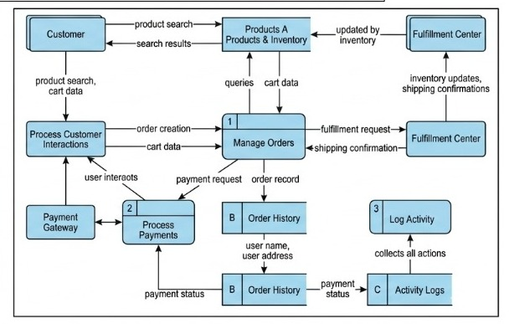


User Stories
Use the below template to list all the user stories for the product.
User Type | Functional Requirement (Epic) | User Story Number | User Story / Task | Acceptance criteria | Priority | Release
Fitness User | User Profile | USN-1 | As a user, I can enter my personal and fitness details to create my profile. | User details are entered and saved successfully | High | Sprint-1
Fitness User | Login | USN-2 | As a user, I can log into the application using my username and password | Valid credentials allow access to the dashboard | High | Sprint-1
Fitness User | Dashboard | USN-3 | As a user, I can log into the application using my username and password | Dashboard displays the user's fitness information and available options. | High | Sprint-1
Fitness User | Fitness Goal | USN-4 | As a user, I can select my fitness goal according to my needs. | Selected fitness goal is saved successfully | High | Sprint-2
Fitness User | Activity Level | USN-5 | As a user, I can provide my activity level and fitness preferences. | Activity level and preferences are recorded correctly. | High | Sprint-2

